M E TA L B
FORM B: CAPITAL APPLICATION

PROJECT NAME: Musha Decline PROJECT LEADER: Neza Damascene CONS. ASS. NO.: DATE: 22/05/2023 CA NO.:

A | PROJECT DESCRIPTION
Background:
The Musha mining site has been a significant source of mineral resources for several years. However, the current mine is gradually reaching its limits and is on the verge of being mined out. As a result, there is a pressing need to explore and access the lower areas of the existing geological package to sustain mining operations and secure the future of Musha Mine.
Project Description:
A mine engineering plan was conducted along with a geotechnical analysis to established the mine plan along with resource, equipment and material requirements. The decline plan along with the breakaway mine plan was also established.
The Musha Decline Project entails the construction of a new decline tunnel with a length of approximately 330 meters. The decline will be engineered with a 9% grade to allow access to the lower levels of the geological package. This expansion will enable the establishment of four additional mining levels, namely levels 5 to 9, opening up new mining operations and extending the lifespan of the mine.
The project will involve the deployment of modern mining equipment, safety measures, and environmental management systems to ensure efficient and responsible resource extraction. It will require a comprehensive feasibility study, geotechnical assessments, and engineering designs to ensure the structural integrity and stability of the new decline.

Ref Number | Fin 02/Form B | Date of Implementation | 01 August 2013
Version | 02 | Date of last revision | 20 June 2022

M E TA L s

B | MOTIVATION
Current Challenges:
- Depletion of Resources: The current mining activities at Musha Tunnel have almost exhausted the available mineral reserves, significantly impacting the productivity and profitability of the mine. Without accessing the lower areas, the mine's operations will be forced to cease, resulting in the loss of jobs and economic opportunities for the local community.
- Artisanal Mining Concerns: In recent years, the Musha mining site has experienced a rise in artisanal mining activities, which pose significant safety and environmental risks. Artisanal mining lacks proper regulations, leading to uncontrolled extraction methods, unsafe working conditions, and environmental degradation. Establishing a new mine through the Musha Decline Project will provide a sustainable alternative to artisanal mining and promote responsible mining practices.
Objectives:
- Ensure Continuity of Operations: The primary objective of the Musha Decline Project is to create a new mine that will allow for the extraction of mineral resources from the lower areas of the geological package. This will ensure the continuity of mining operations at Musha and mitigate the risk of job losses and economic decline in the region.
- Transition to Semi-Industrialized Mining: By establishing the new mine, Musha aims to shift from predominantly artisanal mining practices to semi-industrialized mining operations. This transition will improve safety standards, enhance efficiency and productivity, and comply with environmental regulations.
- Economic Development and Sustainability: The project will contribute to the sustainable economic development of the local community by generating employment opportunities, increasing revenue through mineral exports, and attracting investments in infrastructure and social development projects.
Benefits:
- Job Creation: The establishment of the new mine will create numerous job opportunities, both directly and indirectly, benefiting the local community and improving livelihoods.

Ref Number | Fin 02/Form B | Date of Implementation | 01 August 2013
Version | 02 | Date of last revision | 20 June 2022

M E TA L 5
- Increased Revenue: The project will enhance the revenue generation capacity of Musha through
increased mineral extraction, leading to higher exports and potential partnerships with international buyers.
- Technology and Knowledge Transfer: The introduction of semi-industrialized mining operations will bring advanced technologies, expertise, and best practices to Musha, facilitating knowledge transfer and capacity building for local workers.

C | COSTING SELECTED OPTION
PHASE 1 - Preparation
Items |  |  |  | Unit Cost | Total Qty |  | Total Cost (USD)
Portal and Surface Works |  |  |  |  |  |  | 162,066
I-Beams 305 x 160 x 6 Mtrs |  |  |  | 779 | 17 |  | 13,244
Screen mesh 4mm |  |  |  | 281 | 20 |  | 5,634
Electrical materials |  |  |  | 4,165 |  |  | 4,165
Acetylene and Oxygen bottle and gas |  |  |  | 393 | 4 |  | 1,S72
Steels and Others |  |  |  | 3,072 |  |  | 3,072
Cement 42.5 |  |  |  | 11 | 100 |  | 1,100
Crops Compensation |  |  |  | 220 |  |  | 220
Explosive Magazine Construction  (Appendix) |  |  |  | 10,523 | 1 |  | 10,123
Workshop Extension (Appendix) |  |  |  | 13,384 | 1 |  | 13,384
Workshop Items (Appendix) |  |  |  | 109,552 | 1 |  | 109,552
PHASE 2 - Decline
Development Cost |  |  |  |  |  |  | 605,545
Decline free dig |  |  |  | 471 | 151 |  | 70,918
Decline Blasted |  |  |  | 783 | 380 |  | 297,798
Muck bay |  |  |  | 783 | 47 |  | 36,785
Level Access |  |  |  | 783 | 234 |  | 183,288
Ore pass |  |  |  | 167 | 87 |  | 14,544
Vent Raise |  |  |  | 167 | 13 |  | 2,212
Ref Number |  | Fin 02/Form B | Date of Implementation |  |  | 01 August 2013
Version |  | 02 | Date of last revision |  |  | 20 June 2022

Mining Equipment |  |  | 599,246
LHD | 105,600 | 1 | 105,600
Trucks | 102,500 | 2 | 205,000
Pecker/Excavator | 100,000 | 1 | 100,000
Fans | 5,833 | 2 | 17,500
Pumps | 382 | 3 | 1,146
Box fronts and tips | 34,000 | 5 | 170,000
Water Management System |  |  | 58,023
Grindex Maxi H-Lite Submersible  Pump 29 kW | 2 | 26,408 | 52,817
4” HDPE Pipe | 1000 m | 497 | 4,967
4” Non-return valve | 2 | 120 | 239
Contingency | 15% |  | 213,732
TOTAL COSTS INCLUDING CONTINGENCIES |  |  | $ 1,638,612
*” Please see appendix for long list items that may have been summarized for the sake of this table.

D | RISK ASSESSMENT
- Geotechnical Risks:
  - Geological instability: Thorough geotechnical surveys and assessments, ground reinforcement measures.
  - Rockfalls and collapses: Rockfall protection systems, regular monitoring of rock formations.
- Safety Risks:
  - Accidents and injuries: Strict safety protocols, comprehensive training, regular inspections.
  - Health hazards: Ventilation systems, personal protective equipment (PPE), health screenings.
- Environmental Risks:

Ref Number | Fin 02/Form B | Date of Implementation | 01 August 2013
Version | 02 | Date of last revision | 20 June 2022

- Ecosystem disruption: Environmental impact assessments, habitat protection measures.
- Water and air pollution: Sediment control measures, emission control systems, monitoring.

Financial Risks:
  - Cost overruns: Comprehensive planning, contingency funds, cost control measures.
  - Unreliable resource package: historical geological data will be analysed to ensure resource productivity.

Project Management Risks:
  - Schedule delays: Realistic scheduling, progress monitoring, contingency plans.
  - Resource allocation: Thorough resource planning, effective communication with suppliers.
By addressing these risks with the corresponding mitigation factors, the Musha Decline Project can minimize geological, safety, environmental, financial and project management risks. Implementing these measures will enhance safety, environmental sustainability, regulatory compliance, financial stability, stakeholder engagement, and overall project success.

E |  | PROJECT SCHEDULE
 | Task Name |  |  | Duration
 | Initiation Phase |  |  | 15 days
 | Perform Feasibility Study |  |  | 1 wk
 | Define Project Objectives and Scope |  |  | 1 wk
 | Identify Stakeholders |  |  | 1 wk
 | Develop Project Charter |  |  | 1 wk
 | Planning Phase |  |  | 30 days
 | Identify Equipment Requirements |  |  | 2 wks
 | Develop Procurement Plan |  |  | 1 wk
 | Determine Resource Needs and Labor Allocation |  |  | 2 wks
 | Develop Project Management Plan |  |  | 3 wks
 | Create Work Breakdown Structure (WBS) |  |  | 1 wk
 | Define Project Schedule |  |  | 1 wk
Ref Number |  |  | 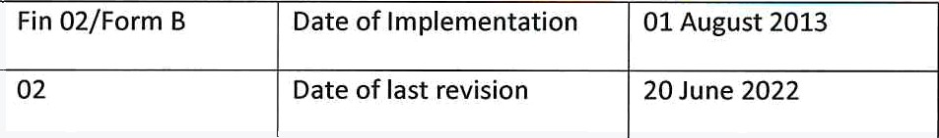  Fin 02/Form B Date of Implementation 01 August 2013  02 Date of last revision 20 June 2022
Version

 | Perform Risk Analysis and Management | 2 wks
 | Execution | 130 days
 | Procure and Mobilize Equipment | 5 mons
 | Hire and Train Labor for Tunnelling Operations | 1 wk
 | Start Tunnelling Operations at Assigned Pace | 1 wk
 | Monitoring and Controlling | 312 days
 | Monitor Project Progress | 13 mons
 | Perform Quality Inspections and Assurance | 13 mons
 | Manage Risks and Issues | 13 mons
 | Control Project Scope | 13 mons
 | Control Project Schedule | 13 mons
 | Control Project Costs | 13 mons
 | Closing | 11 days
 | Complete Tunnelling Operations | 1 day
 | Perform Final Inspections and Testing | 1 wk
 | Document Lessons Learned | 1 wk
 | Conduct Project Review and Evaluation | 1 wk
 | Close Contracts | 1 wk
 | Handover Project Deliverables | 1 wk
”” Please find attached to this application the associated Gannt Chart for the project along with the allocated resources. (ignore actual dates)

F | COMMENTS
GROUP
FINANCE
Ref Number |  |  | Fin 02/Form B | Date of Implementation | 01 August 2013
Version |  |  | 02 | Date of last revision | 20 June 2022

M E TA L B
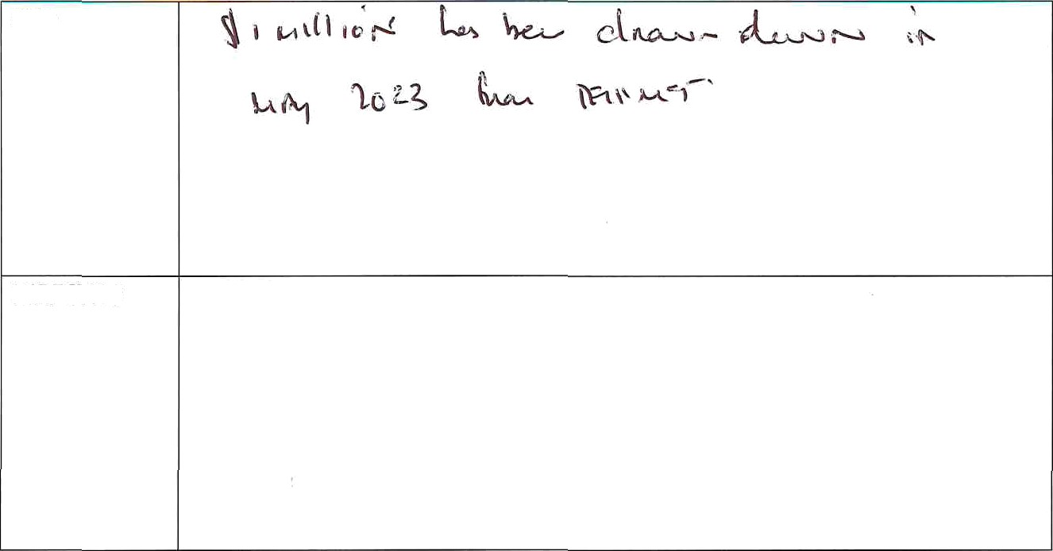
CEO
DIRECTOR

G | APPROVAL
CEO |  | 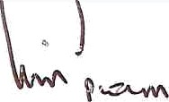      cEo •f Trinity Metals Group  *880841959034
BOARD |  | 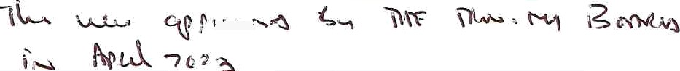

NOTE: attach additional quotes or supporting documents if necessary

Ref Number | Fin 02/Form B | Date of Implementation | 01 August 2013
Version | 02 | Date of last revision | 20 June 2022

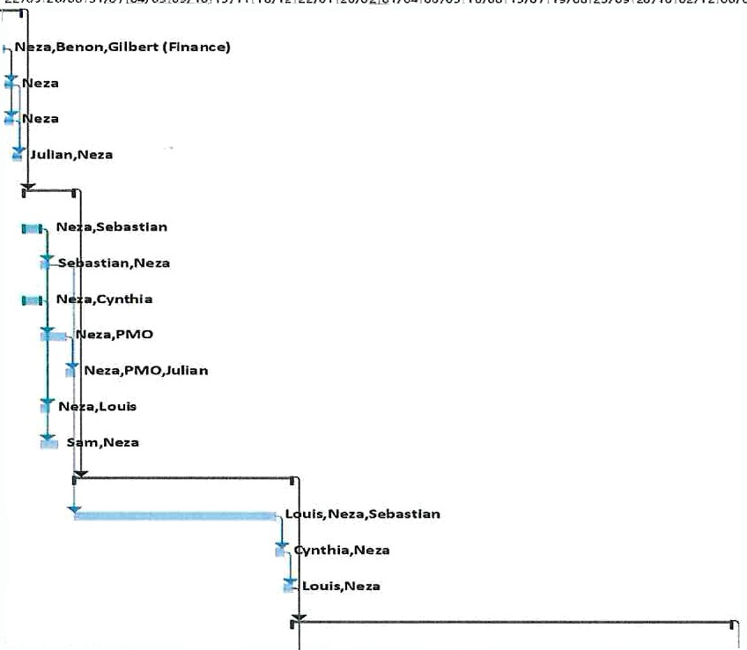
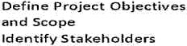

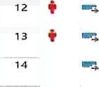
T R I N I TY
PerJ'orm Fee lib laity Study z wk
Wed J7/O5/z3
Requ Trem ents
O#velop Proc mm ant Plan 4 wk
Dale rm Tn e R eeourca Ne eds 2 wk and La6or ATlow*Jon
Develop Pro}eot E Ma negeme nt Pla u
arena Work Breekdoin y wk
o n no»mnueuee ink
rwza/oe zs
.:.. :..:..: naUiveMi‹euone
Milatone

Pr gject Summary
I Sten-only FinTsh-one External TasM
M E TA L E
Appendix A
Long-Term Schedule - Gannt Chart

Ref Number | Fin 02/Form B | Date of Implementation | 01 August 2013
Version | 02 | Date of last revision | 20 June 2022

%

T R I N I TY
M E TA L S

zo fi -+

ee rform Qu al ity
insp ection s and Asso ra nce

con trod PrOject 5 co p e Contra I Project 5ched ule

No m p Pete Tun n elling Perform Fin a I Inspentio ns
io.ea man r ri is/or/24
to.sa rri zsyoa/ze
W0 N5
ao.aa mon rri zs/ozyzs
ao.sa man rri is/oz/zs

TO.8 3 m on F ri :t9/O1/ 74

1 day Fri IT/ 01/ 25

close contracts I we rvion zo/ozyzs

Ha nd o ver P roje ct Oe Iiver ad I Wk M o n 2T /01/R

Date: Mon W/0S/23

Pi aject Summ ary
I na ctive Task Inactive Milestone I na ctive Summary Manu al Task
Manual So m ma ry Roll up Manual Su mrna ry
Start-only Finish-o my
Extenaal Ta sks
Extern al Milestone

Progress
Manual Progress

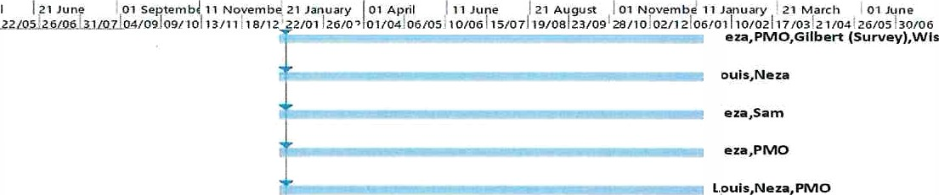
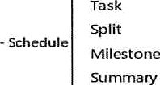

Ref Number | Fin 02/Form B | Date of Implementation | 01 August 2013
Version | 02 | Date of last revision | 20 June 2022

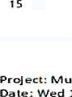
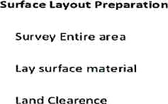
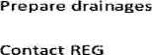
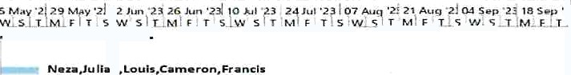
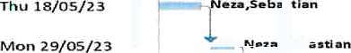

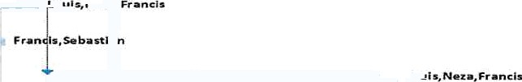

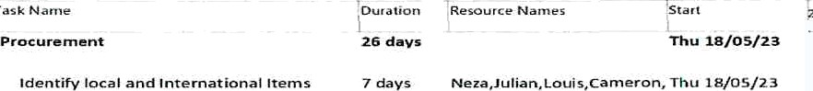
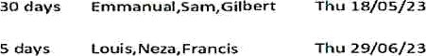
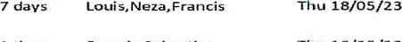
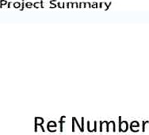
6-Month (Short Term) — Gannt Chart
Commence ordarJog process
G4 days mbas than
Min OS/6/23
days Wiadom.W Iber$
yQ days God s,Noa.bunchs
-S

 | Fin 02/Form B | Date of Implementation | 01 August 2013
Version | 02 | Date of last revision | 20 June 2022


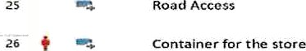
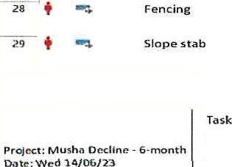
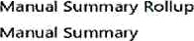

External Milestone
. @,adIIr+a
.
Inactive Ta*k
Inactive Mflestone
Split
Eac¥vate portal enhance to same some as TO days Wufs.Nora

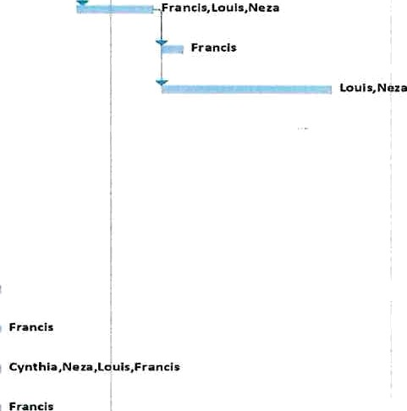

Ref Number | Fin 02/Form B | Date of Implementation | 01 August 2013
Version | 02 | Date of last revision | 20 June 2022

TRI N ITY
M E TA L S

Appendix B
Workshop Tools and Materials
No | Description | UoM | Quantity | Unit Price range | Average
1 | Elevator 15 tons | set (complete) | 1 | $30,000 to $50,000 | $40,000.00
2 | Lifting crane 15 tons | set (complete) | 1 | $20,000 to $40,000 | Ș30,000.00
3 | Tool Box (Complete tool kit) | set (complete) | 1 | $5,000 to $10,000 | $7,500.00
 | 3/4 Tool Box | set (complete) | 1 | $1,000 to Ș2,000 | $1,500.00
5 | 1/8 Tool Box | set (complete) | 1 | $500 to $1,000 | $750.00
6 | Air compressor 10 Hp | set (complete) | 1 | $3,000 to $5,000 | Ș4,000.00
7 | Air line setup | set (complete) | 1 | $500 tO $1,000 | $750.00
8 | Impact wrench (Heavy duty) | set (complete) | 1 | $500 to $1,000 | $750.00
9 | Gear Puller 2 jaws | Pc | 1 | $50 tO $100 | $75.00
10 | Gear puller 3 jaws | Pc | 1 | $100 to $200 | $150.00
11 | Twin and Triple reversible Leg Puller | Pc | 1 | $100 to $200 | $150.00
12 | Piston Ring Compressor | Pc | 1 | $S0 to $100 | $75.00
13 | Trolley Racing Jack 12 tons | Pc | 1 | $500 to $1,000 | 5750.00
14 | Shop press with hand pump 50 tons | Pc |  | $1,000 to $2,000 | $1,500.00
15 | Battery Charger (Power Booster) | Pc |  | $200 to $500 | $350.00
16 | Booster Cables | set |  | $50 tO $100 | $75.00
17 | Magnetic Pick-up Tool | Pc | 1 | $10 to $50 | $30.00
18 | Auto detector an diagnosis Machine | set | 1 | $5,000 tO $10,000 | $5,000.00
19 | CAT program | set |  | $500 tO $1,000 | $5,250.00
20 | Renault Program | set | 1 | $500 to $1,000 | $750.00
21 | Standard Garage creeper | Pc | 1 | $50 to $100 | $75.00
22 | Valve Grinder | Set | 1 | $500 to $1,000 | $750.00
23 | Ball joint Separator | Pc | 1 | $50 to $100 | $75.00
24 | Tyre repair machine with all kits | set | 1 | $500 to $1,000 | $750.00
25 | Tag & die | set | 1 | $50 to $100 | $75.00
26 | Mechanic Vice-grip | set | 1 | $20 to $50 | Ș35.00

Ref Number | Fin 02/Form B | Date of Implementation | 01 August 2013
Version | 02 | Date of last revision | 20 June 2022

T R I N I TO
M E TA L S

27 | Rust spray | set | 1 | $10 to $50 | $30.00
28 | Centre Punch | set | 1 | $5 to $20 | $12.50
29 | Chisel | set |  | $10 to $S0 | $30.00
30 | Files | set | 1 | $10 to $50 | $30.00
31 | Hacksaw square tube | pc | 1 | $20 to $50 | $35.00
32 | Table-vice | pc |  | $50 to $100 | $75.00
33 | Small grinder (Air-pressure operated) |  |  | 550 to $100 | $75.00
34 | Wire wheels (Brush for grinder) | p^ | 5 | $l0to $50 | $150.00
35 | Chain Broker 750 Kg, 1.5 ton, 3 tons, 5 Tons | set | 1 | $50 to $200 | $125.00
36 | Tanganyika jack | Pc | 1 | $100 to $200 | $1S0.00
37 | Air operated grease pump | Pc | 1 | $100to $200 | $150.00
38 | Air operated Oil pump | Pc | 3 | $100 to $200 | $450.00
39 | Trestle Reticle 12 Tons | Pc | 1 | $500 to $1,000 | $7s0.00
40 | Standard Fording crane Hydraulic | Pc | 1 | $5,000 to $10,000 | $7,s00.00
41 | Torque Wrench 3/4, 1/2, 1" | Pc |  | $200 to $500 | $1,050.00
42 | Vernier caliper digimatic | Pc | 1 | $50 to $200 | $125.00
43 | Socket HEX | set | 1 | $10 to $50 | $30.00
44 | Socket Hexagon Bit 1/2 | set | 1 | $10 to $50 | $30.00
45 | socket with Spline drive 1/2 | set | 1 | $10 to $50 | $30.00
46 | Long nose prier | Pc | 1 | $10 to $50 | $30.00
47 | Water pump prier | Pc | 1 | $10 to $S0 | $30.00
 | Total |  |  |  | $109,552.50

Workshop Extension and Construction
1 | Cement | Bag | 60 | $12.65 | $759.00
2 | Corrugated Root Sheet 28 gauge of  90 cm x 9 m | Pcs | 30 | $30.00 | $900.00
3 | Smooth Sand | Trips | 5 | $0.00 | $0.00
4 | Wire mesh (50 x SO x 3mm) | m2 | 200 | $50.00 | 10,000.00
5 | Angle lines of (40 x 40 x 3 mm) | Pcs | 10 | 52500 | $250.00

Ref Number | Fin 02/Form B | Date of Implementation | 01 August 2013
Version | 02 | Date of last revision | 20 June 2022

M E TA L B
6 | Rebar 16 @ mm | Pcs | 4 | $16.00 | $64.00
7 | BRC Mesh | m2 | 80 | $2.00 | $160.00
8 | Twin Cables 2.5 mm x 2 core | Rolls |  | $70.00 | $280.00
9 | Flexible cable 3 x 4 mm | Rolls | 2 | $100.00 | $200.00
10 | LED water proof tubes with fittings | set | 10 | $2.00 | $20.00
11 | Industrial Male& Female Plugs with  32 A | Set | 10 | $3.00 | $30.00
12 | Cable ties 7.8 mm | Pcs | 5 | $0.00 | $0.00
13 | Wall switches | Pcs | 5 | $3.00 | $15.00
14 | Wall socket Outlet | Pcs | 10 | $0.00 | $0.00
15 | Junction Box 70 x 70 x 10 mm | Pcs | 15 | $2.00 | $30.00
16 | Circuit Breaker 40 A (Three Phase) | Pc | 1 | $60.00 | 360.00
17 | Circuit Breaker 32 A (single Phase} | Pc | 1 | $7.00 | $7.00
18 | Circuit Breaker 16 A (single Phase) | Pc | 2 | $5.00 | $10.00
19 | Aggregat | Trips | 3 | $0.00 | $0.00
TO | Main Distribution Board | Pc |  | $12.00 | $12.00
Z1 | Conduit Pipes 20 mm | Pcs | 50 | $0.20 | $10.00
22 | Ventilation Fans 2 KW | Pcs | 4 | $100.00 | $400.00
23 | PPR Pipes 3/4 | Pcs | 20 | $1.05 | $21.00
24 | PPR bends 3/4 | Pcs | 15 | $1.00 | $15.00
25 | Valve GI | Pcs | 5 | $10.00 | $50.00
26 | Adapters | Pcs | 15 | 2.00 | $30.00
27 | Trend Tape | Pcs | 10 | $3.00 | $30.00
28 | Tapes 3/4 | Pcs | 3 | 2.00 | $6.00
29 | Solvent cement | Kg | 1 | $10.00 | $10.00
30 | self-taping screws | Pcs | SOO | $0.03 | $15.00
 | Total | $12,625.00

e

Ref Number | Fin 02/Form B | Date of Implementation | 01 August 2013
Version | 02 | Date of last revision | 20 June 2022

M E TA L S

Explosive Magazine Cost
NO | NAMES | UNIT | QUANTITY | UNIT COST (RWF) | TOTAL COST (RWF)
 | IRON SHEET | Pcs | S0 | 18,600.00 | 930,000.00
2 | TUBE(60 X40 X 2 MM) | Pcs | 57 | 55,000.00 | 3,135,000.00
3 | TUBE(40X 40X 2 MM) | Pcs | 31 | 40,000.00 | 1,240,000.00
4 | WELDED MESH (50 X 50 X 3 MM) | Pcs | 25 | 50,000.00 | 1,250,000.00
S | ANGLE LINE(50 X 50 X 3 MM) | Pcs | 3 | 30,000.00 | 90,000.00
6 | SLIDING GATE | Pcs | 4 | 300,000.00 | 1,200,000.00
7 | REDOXIDE PAINT | Bucket | 12 | 11,500.00 | 138,000.00
 | GUTTER(4 M) | M | 8 | 20,000.00 | 160,000.0O
9 | STONES | Truck | 40 | 0.00 | 0.00
10 | CEMENT | Bags | 120 | 12,650.00 | 1,518,000.00
12 | ROUNDBAR 12a | Pcs | 32 | 12,500.00 | 400,000.00
13 | ROUNDBAR6@ | Pcs | 34 | 6,000.00 | 204,000.00
14 | GALVINISEDWIRE | Kgs | 10 | 1,640.00 | 16,400.00
15 | NAILS 8cm | Kgs | 10 | 1,450.00 | 14,500.00
16 | NAILS 6cm | Kgs | 5 | 1,450.00 | 7,250.00
17 | PLANKS | Pcs | 40 | 5,500.00 | 220,000.00
18 | SAND | Truck | 8 | 0.00 | 0.00
19 | AGGREGATES | Truck |  | 0.00 | 0.00
 | TOTAL |  |  |  | 10,523,150.00

Ref Number | Fin 02/Form B | Date of Implementation | 01 August 2013
Version | 02 | Date of last revision | 20 June 2022

