CONTRACT NO: 0000001997

NTUNGA PEGMATITE PROCESS AMENABILITY SAMPLE STORAGE AND TEST WORK

PROFESSIONAL SERVICES AGREEMENT

AMENDMENT NUMBER 2

23 APRIL 2026

FINANCIAL QUERIES TO: GRATIEN MANIRIHO TEL: +250 785 617 997

TECHNICAL QUERIES TO : RONALD TOLEDO TEL: +250 791 345 778

COMMERCIAL QUERIES TO: JEOME SANDE TEL: +250 782 369 340

COMPANY:- CONTRACTOR:-

TRINITY MUSHA MINES LIMITED ALFRED H KNIGHT
MUSHA, RWAMAGANA,, UNIT 14 TRESILLIAN BUSINESS PARK,
EASTERN PROVINCE, TRURO, CORNWALL TR2 4HF,
RWANDA ENGLAND

AMENDMENT 2, TO:

UPDATE DUE TO IMPLEMENTATION OF SAMPLE TESTING:
- CLAUSE 4 “DURATION”,
- CLAUSE 5 “COST AND PAYMENT TERMS”
- ANNEXURE “B“ RATES AND COST TO REFLECT UPDATED PROCESS AMENABILITY
TESTING COSTS

- SCOPE OF AMENDMENT
On behalf and for account of the Company it is confirmed that the Contract is hereby Amended:
- By the deletion of clauses:
4.) DURATION
and
5). COST AND PAYMENT TERMS
and
ANNEXURE “B” STORAGE

and the substitution therefore with:

4.) DURATION
The Contract shall commence 12 September 2025 and terminate on successful conclusion of Sample Test Work.

Sample Storage shall commence 25 September 2025 with an estimated Storage End Date of 30 June 2026.

In the event that Test Work commences during the Sample Storage period, the Contractor shall reimburse the Company for any and all Storage Costs paid in excess of the Test Work date.

Sample Test Work shall commence on the written instruction of the Company and will be undertaken within an estimated 17 week programme.

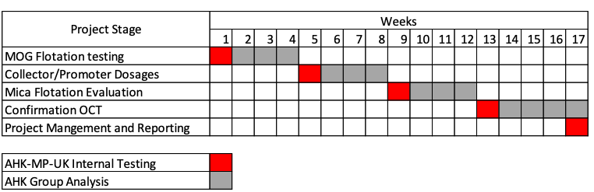

5.) COST AND PAYMENT TERMS

The Company shall pay to the Contractor the Fees and Rates as detailed in Annexure “A” hereto.

The fees shall be payable:
5.1 Storage Costs British Sterling 1 575.00 Per Quarter

5.2 Test Work British Sterling 10 309.50 prior to commencement and British Sterling 10 309.50 on completion of Test Work and prior to the issue of the Test Report.

ANNEXURE “B”
RATES AND COST
Line Item | Description | Unit Price | Qty | Total
1 | Ntunga Pegmatite Process Amenability – Storage of 2 Pallets with an Estimated Storage end date of 30 June 2026. | B.Sterling  787.50 | 2 | B.Sterling  1 575.00
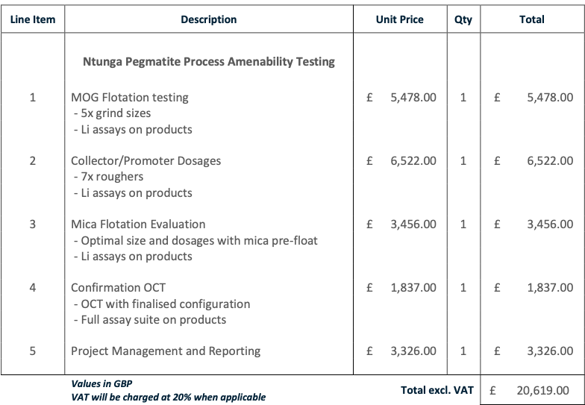

- AMENDMENT DATE

Except as herein provided, all other terms and conditions of the Services Contract remain unchanged.

For and on behalf of:

TRINITY MUSHA MINES LIMITED

Ronald Toledo
Name Name

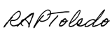
Signature Signature

Group Metallurgist ………………………
Designation Designation

29/4/2026 ………………………
Date Date

For and on behalf of:

ALFRED H KNIGHT

………………………………………
Name

………………………………………
Signature

………………………………………
Designation

………………………………………
Date

