
Gisiminti, Ikaze House , Gasabo District, Kigali, Rwanda.
Tel: + 250 788354937
Email: waltd282@gmail.com
Customer
Name :RUTONGO MINES LTD/ Trinity Metals Ltd
Date 21-Apr-26
City:Kigali
Country;Rwanda Quotation Number : 0071/04/2026
SUPPLY OF ROLLER CRUSHER PARTS AND INSTALLATIONS | Q'ty | RWF | TOTAL
 |  |  | RWF
Supply and install Roller crusher parts as follows ; BEARING  HOUSING MCB-211 ; ROLLER  MACHINING 250DIAX295; ROLLER  CASTING 77KGs ; ROLLER  PATTERN; Shaft material; BOLTS M-18x315 ; Cover plates; 150diax14mm ; and Transport costs from Kigali to Rutongo Mines ( Attached is the design) | 1 | 12,079,237 | 12,079,237
ADD VAT 18% |  |  | 2,174,263
TOTAL Amount all Taxes Inclusive |  |  | 14,253,500
Delivery period:
- Advance Payment of 50% balance payable within 10 days after delivery
- Delivery period is 30 days


Bank Payment Details
Bank: EQUITY BANK
Branch: Main Branch
Account name: WORLD ACCESS LTD
Account type: RWF
Account No: 4069200045136
BIC/SWIFT code: EQBLRWRW XXX
VAT NO.103762257

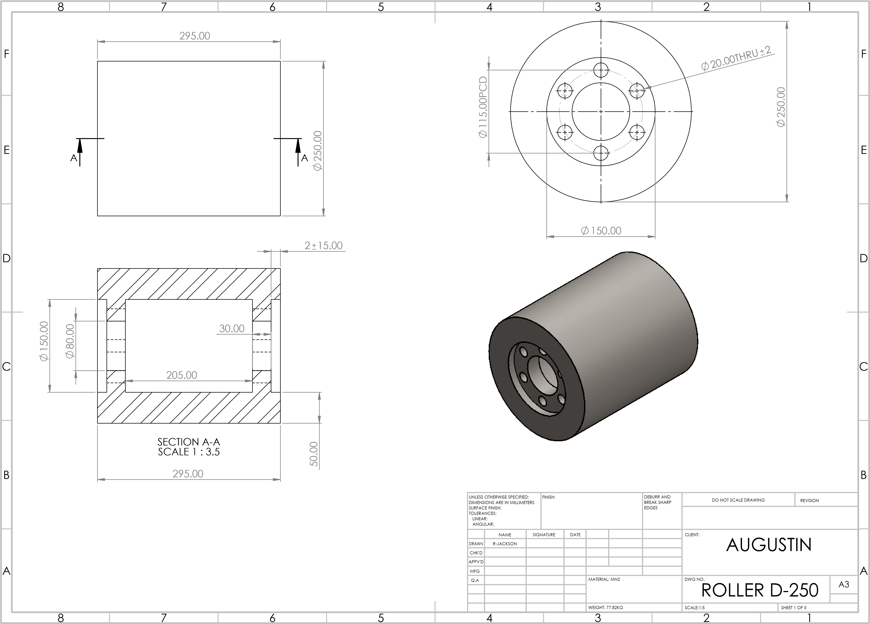

8 |  | 7 | 6 | 5 |  | 4 |  |  |  | 3 |  |  |  | 2 |  | 1
F |  | 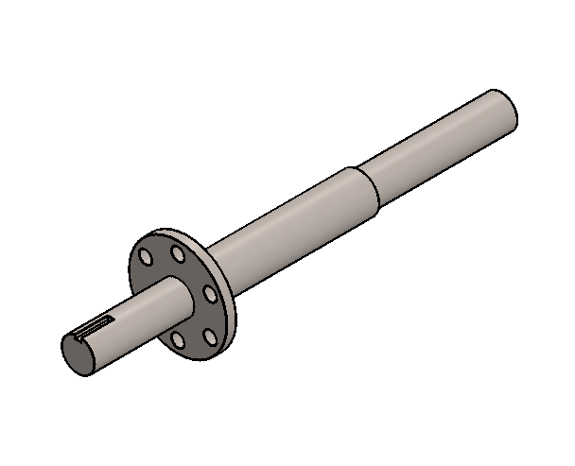  150.00  20.00  10.00X6X40  B  B  50. |  |  | 00 | 14.00 |  |  |  | 50.00  60.00  650.00  150.00  SECTION B-B  SCALE 1 : 3.5 |  |  |  |  |  |  |  |  |  | F
E |  |  |  |  |  |  |  |  |  |  |  |  |  |  |  |  |  |  |  | E
D |  |  |  |  |  |  |  |  |  |  |  |  |  |  |  |  |  |  |  | D
C |  |  |  |  |  |  |  |  |  |  |  |  |  |  |  |  |  |  |  | C
B |  |  |  |  |  |  |  |  |  |  |  |  |  |  |  |  |  |  |  | B
 |  |  |  |  |  | UNLESS OTHERWISE SPECIFIED: DIMENSIONS ARE IN MILLIMETERS SURFACE FINISH:  TOLERANCES:  LINEAR:  ANGULAR: |  |  | FINISH: |  |  |  | DEBURR AND  BREAK SHARP  EDGES |  | DO NOT SCALE DRAWING |  |  | REVISION |  | B
A |  |  |  |  | 00 |  | NAME | SIGNATURE |  | DATE |  |  |  |  | TITLE: |  |  |  |  | A
 |  |  |  |  |  | DRAWN | R-JACKSON |  |  | 21/04/26 |  |  |  |  |  |  |  |  |  | A
 |  |  |  |  |  | CHK'D |  |  |  |  |  |  |  |  |  |  |  |  |  | A
 |  |  |  |  |  | APPV'D |  |  |  |  |  |  |  |  |  |  |  |  |  | A
 |  |  |  |  |  | MFG |  |  |  |  |  |  |  |  |  |  |  |  |  | A
 |  |  |  |  |  | Q.A |  |  |  |  | MATERIAL: |  |  |  | DWG NO. ROLLER SHAFT |  |  |  | A3 | A
 |  |  |  |  |  |  |  |  |  |  | WEIGHT: |  |  |  | SCALE:1:5 |  | SHEET 2 OF 5 |  |  | A
A | 8 | 7 | 6 | 5 |  | 4 |  |  |  | 3 |  |  |  | 2 |  | 1 |  |  |  | A
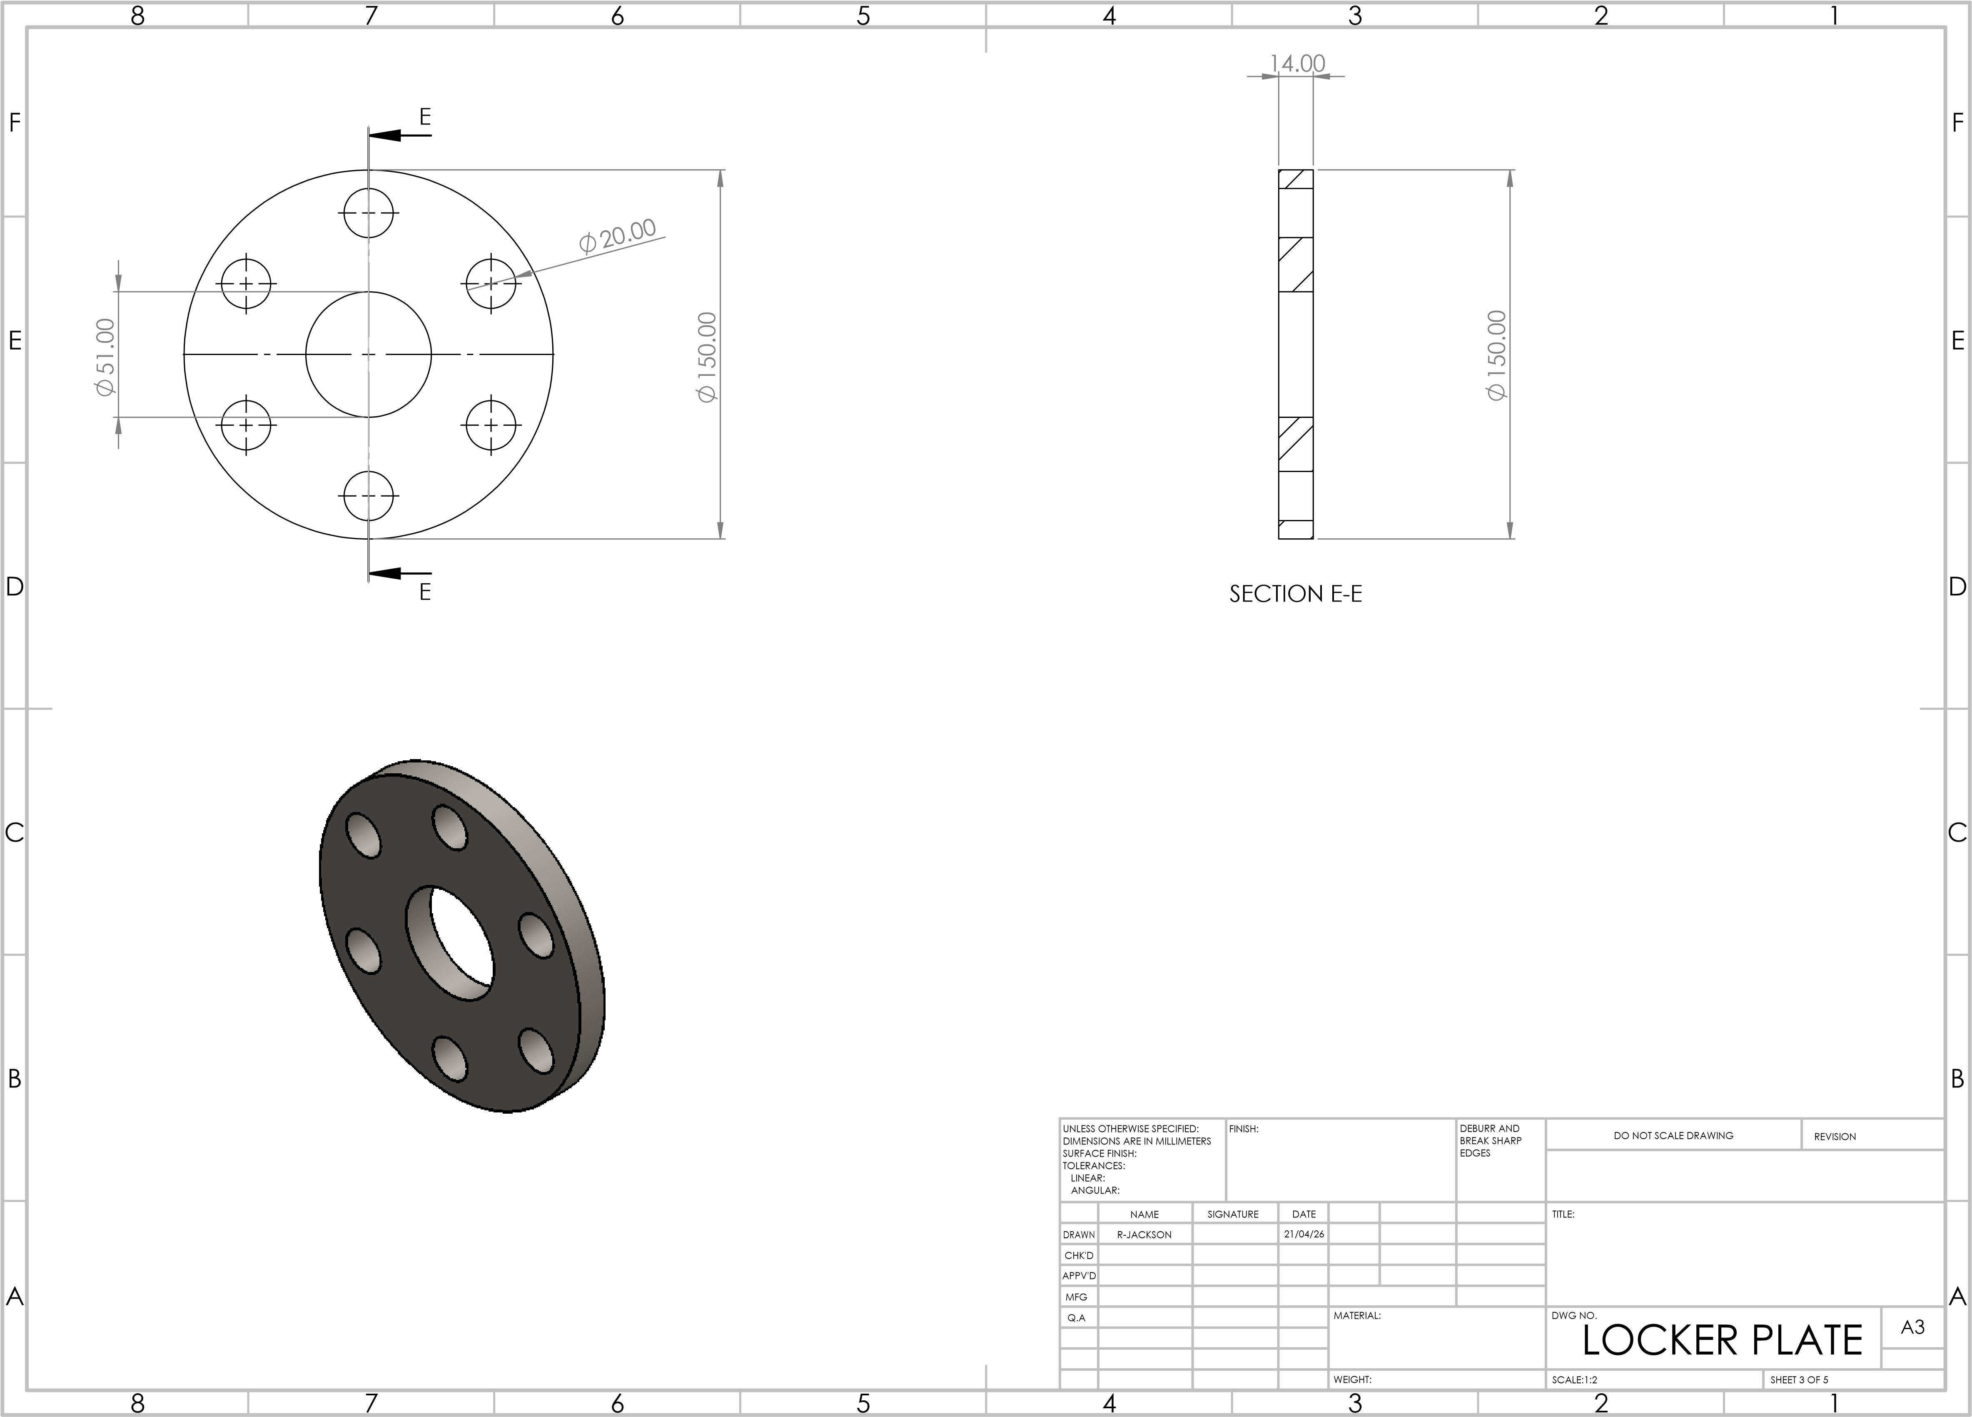
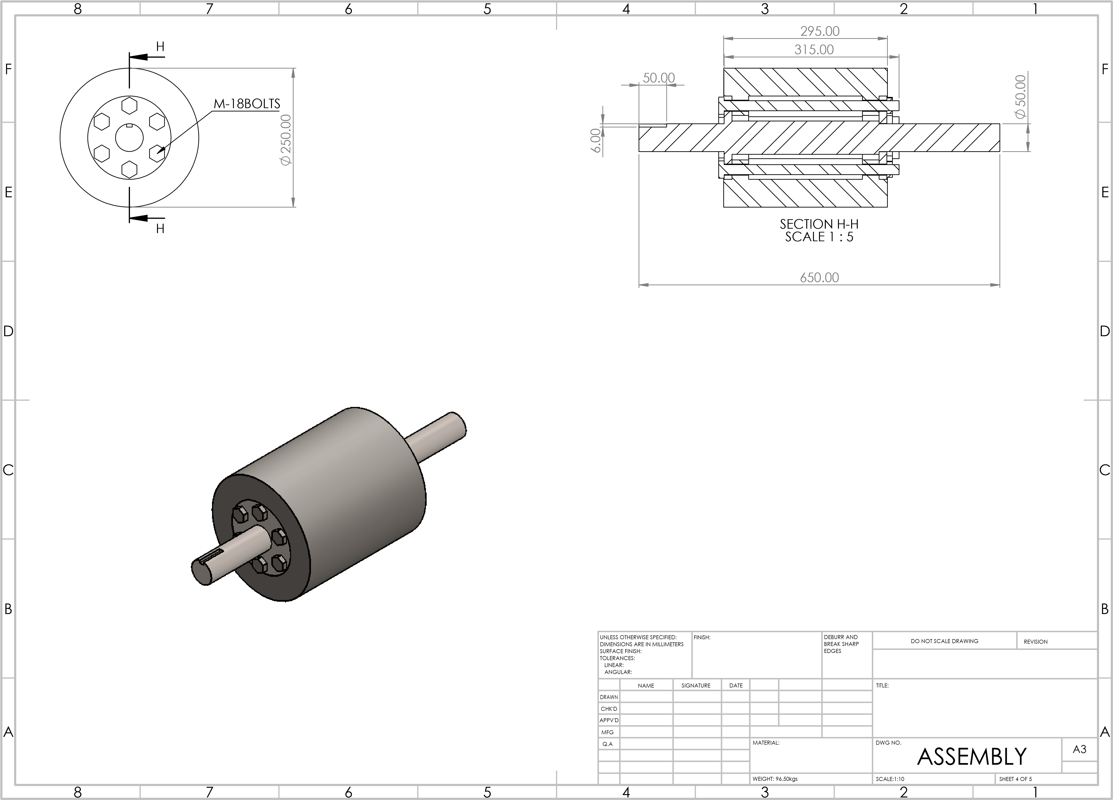

8 |  | 7 | 6 | 5 |  | 4 |  |  | 3 |  |  |  |  | 2 |  | 1
F | M-18  48.02  6  10.00  M-18  G  G SECTION G-G  SCALE 2 : 1 |  |  |  | PCS | 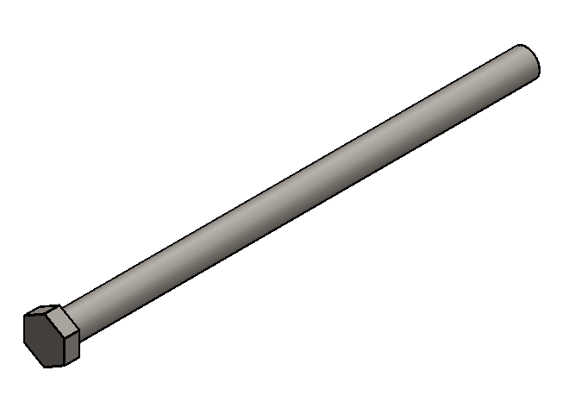  SIX PCS 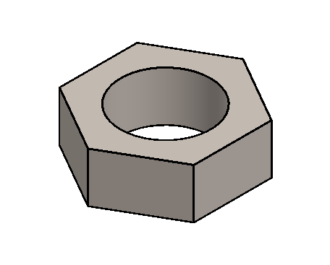 |  |  |  |  |  |  |  |  |  |  |  |  |  | F
E |  |  |  |  |  |  |  |  |  |  |  |  |  |  |  |  |  |  |  | E
D |  |  |  |  |  |  |  |  |  |  |  |  |  |  |  |  |  |  |  | D
C |  |  |  |  |  |  |  |  |  |  |  |  |  |  |  |  |  |  |  | C
B |  |  |  |  |  |  |  |  |  |  |  |  |  |  |  |  |  |  |  | B
B |  |  |  |  | PCS | UNLESS OTHERWISE SPECIFIED: DIMENSIONS ARE IN MILLIMETERS SURFACE FINISH:  TOLERANCES:  LINEAR:  ANGULAR: |  |  | FINISH: |  |  |  | DEBURR AND  BREAK SHARP  EDGES |  | DO NOT SCALE DRAWING |  |  | REVISION |  | B
A |  |  |  |  | PCS |  | NAME | SIGNATURE |  | DATE |  |  |  |  | TITLE: |  |  |  |  | A
A |  |  |  |  | PCS | DRAWN | R-JACKSON |  |  | 21/04/26 |  |  |  |  |  |  |  |  |  | A
A |  |  |  |  | PCS | CHK'D |  |  |  |  |  |  |  |  |  |  |  |  |  | A
A |  |  |  |  | PCS | APPV'D |  |  |  |  |  |  |  |  |  |  |  |  |  | A
A |  |  |  |  | PCS | MFG |  |  |  |  |  |  |  |  |  |  |  |  |  | A
A |  |  |  |  | PCS | Q.A |  |  |  |  | MATERIAL: |  |  |  | DWG NO. BOLT 8.8 |  |  |  | A3 | A
A |  |  |  |  | PCS |  |  |  |  |  | WEIGHT: |  |  |  | SCALE:1:5 |  | SHEET 5 OF 5 |  |  | A
A | 8 | 7 | 6 | 5 |  | 4 |  |  | 3 |  |  |  |  | 2 |  | 1 |  |  |  | A

