
Earthworksquarrying Ltd: Excellence in every detail.

QUOTATION
Quotation No: ERUTQ-SC-2025-002
Date: 05/3/2026
Attention to: Athanase NDAHAYO
Company name: Rutongo Mines Ltd
TIN: 101907021 (Rulindo, Northern Province) We are pleased to provide our quotation as follows:
Item Description | Quantity | Unit (Rwf) | Price | Discount rate offered | Total (Rwf)
XRF Sample Cups with Thermoplastic® Seal  Venting External  Overflow Reservoirs and Serrated Edge "Snap-On Ring", Single Open End.  1.22" (31.0mm) O.D. X  0.87" (22.1mm) High | 1 pack of 50  cups | 600000 |  | 2% | 580000
EBM will be provided.
The payment should be made to our Equity Bank as per below:
Account Name: Earthworks quarrying ltd.
Account number: 4033201284974
Payment terms: 100% upfront
Delivery Time: Within three (3) days upon payment.
Quotation Validity: One (1) month from the date of issue.
We look forward to serving you.
Selling spare parts of different machines used in mining and quarrying
Laboratory consumables
Support services to mining companies and construction sites

Earthworksquarrying ltd: Excellence in every detail.

Sincerely, 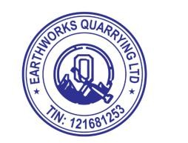
Earthworks Quarrying Ltd
Selling spare parts of different machines used in mining and quarrying
Laboratory consumables
Support services to mining companies and construction sites

