Machines-Outils Ltd Kigali, on 09/03/2026
P.O.BOX:5316 Kigali Tel
TIN/VAT:101954280
Email:machinesoutilsltd@gmail.com
To

Procurement officer of RUTONGO MINES LTD
Re :lnspection report
Good morning ? After conducting an inspection on the machines in the laboratory which are 2 rollers : First roller is made in manganese then need to replace with new roller ; Secand roller is made in steel then need to repair so duration of repair of steel roller is I week.
Our suggestion
l . 2 rollers with blockbearing for each machine cost rwfx rwf
- Repair rollers + blockbearing for I machine cost rwf
- New roller crusher machine cost rwf
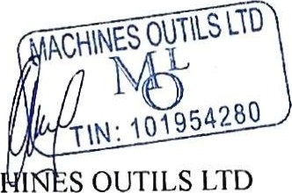
Thanks
OUTILS
S
BAVUGAYABO P.Celestin
Managing Director of MAC

