SITE WORKS & SERVICES WORK COMPLETION CERTIFICATE No: …………
MINE NAME: RUTONGO MINES LTD.
DATE: 4/11/2025

PROJECT TITLE | PROPOSED RESTRUCTURING
PO/CONTRACT NO. | PO0000004884
NAME OF CONTRACTOR | ENSafrica Rwanda
STATUS OF COMPLETION (%) | 100% implemented
GROSS INVOICE VALUE (INCLUDING VAT & WITHHOLDING TAXES) | 8,352,748
VAT – payable by Trinity Metals to Rwandan Revenue Authority | Inclusive
WITHHOLDING TAX – payable by Trinity Metals to Rwandan Revenue Authority | None

NET AMOUNT PAYABLE to International Contractor

(EXCLUDING VAT & WITHHOLDING TAXES)
Contract Value NET AMOUNT PAYABLE (EXCLUDING VAT & WITHHOLDING TAXES) |  | Contract Balance (PO/Contract Value minus Invoices)
Currency: USD PO/Contract Value:
Invoice No. #NV010-10004915 | Amount: FRW8,352,748
Invoice No. | Amount:
Invoice No. | Amount:
Invoice No. | Amount:
Invoice No. | Amount:

APPROVAL

DOA | NAME | DESIGNATION | SIGNATURE | DATE
MANDATORY: TRINITY PR HOD | UMUHIRE MARTINE | LEGAL AND COMPLIANCE SPECIALIST | 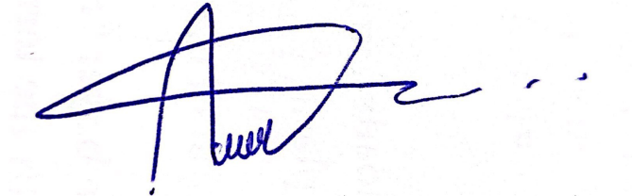 | 4/11/2025

MANDATORY: MINE FINANCIAL MANAGER

MANDATORY: GROUP SUPPLY CHAIN MANAGER

GENERAL MANAGER (UP TO $50K)

COO (>$50K to $100k)

CFO (>$100K to $250k)

CEO (>$250k to $400k)
MINE FINANCIAL MANAGER PAYMENT/TELEGRAPHIC TRANSFER | DATE PAID/BANK INSTRUCTED: | DATE TELEGRAPHIC TRANSFER: |  | AMOUNT:

