Overview
Trinity Metals Limited is the largest mining company in Rwanda, with three assets: Rutongo Mine, Trinity Nyakabingo Mine and Trinity Musha Mines. Trinity Metals Limited was formed in May 2022 with the amalgamation of the three mines. The Company is committed to the expansion, modernisation and mechanisation of its activities, and to addressing mining-related environmental and social impacts in a responsible and sustainable manner.
Trinity Metals seeks to engage the services of a Rwandan-based GIS company to provide GIS mapping and spatial analysis services in support of key environmental and social projects underway at all three of the mining concessions. In addition, Trinity Metals requires GIS-based support for mining-related activities: such as land acquisition; mine planning and closure; and rehabilitation, and asset protection and SHEC management functions.
Ultimately, Trinity Metals intends to establish its own internal GIS capacity which will build on the deliverables supplied by an external service provider, covered in this scope of works.

Project Background
Trinity Metals Limited (the Company) is a privately owned company engaged in the mining and exploration of tin, tungsten, tantalum and lithium in Rwanda. The Company is currently developing and operating three mining complexes in Rwanda near the city of Kigali: Rutongo Mine (tin); Trinity Nyakabingo Mine (tungsten); and Trinity Musha Mine (tin and tantalum, with lithium exploration) – Figure 1.
All three mines have a long history of artisanal-scale mining dating back to the Belgian times in the late 1930’s. This has resulted in significant environmental and social legacy issues, including altering the natural hydrological functioning of the river systems and water quality impacts.
Trinity Metals has recently updated the Environmental and Social Impact Assessments (ESIAs) and Management Plans for all three mines in line with Rwandan law and international best practice. The ESIAs are informed by comprehensive specialist baseline assessments.

Rutongo Mines
Rutongo Mines sit 26km north of Kigali (Fig 1), comprising six underground tin mines – Gisanze, Masoro, Nyamyumba, Gasambya, Karambo and Mahaza (Fig 2). Together, they contain one of the biggest cassiterite (tin ore) deposits in Africa.
Located in the Rulindo District, the mine occupies a vast mining concession (9600ha) which is densely populated by rural communities and intensively cultivated in areas not designated for active mining. It is estimated as hosting a population of >90 000 (2022 census). Large areas of the concession are designated state forests (mainly eucalyptus) and labour-intensive aggregate mining takes place along most of the rivers.
RML employs a workforce of ~2500 with the vast majority sourced from the communities located within the concession area.
The long mining history of Rutongo Mines has resulted in extensive mining legacy issues in the form of old underground mine workings, tunnel entrances (mostly barred) and tailings dumps.
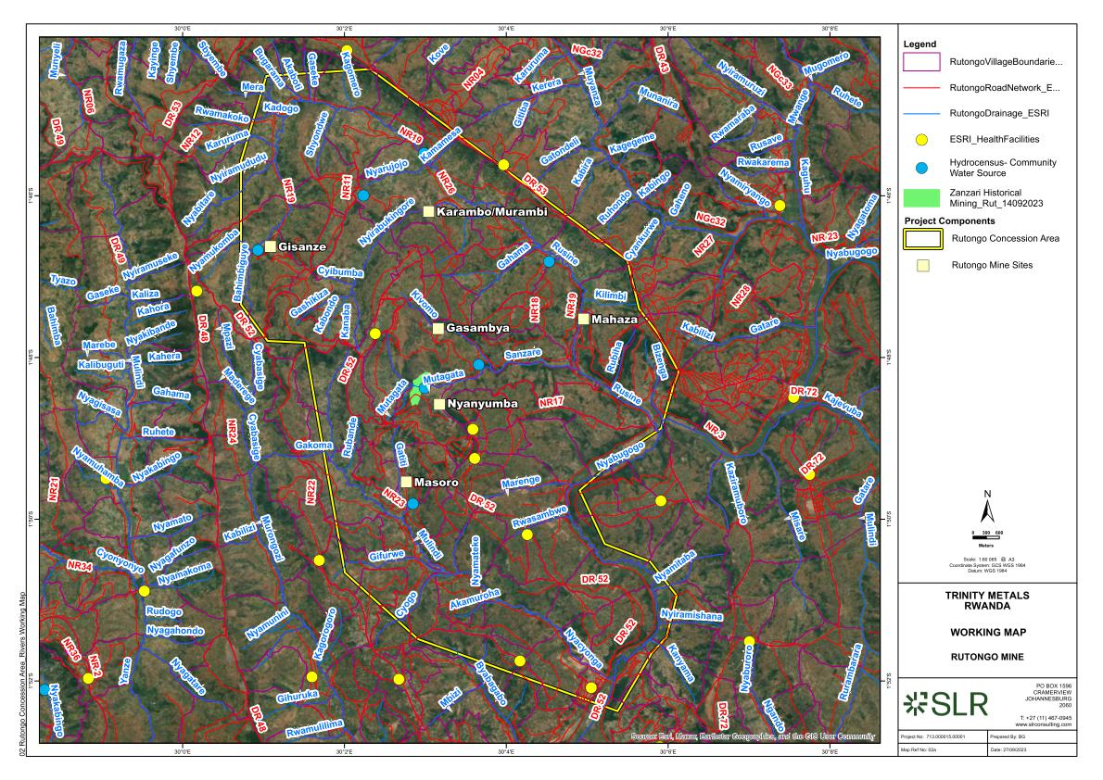
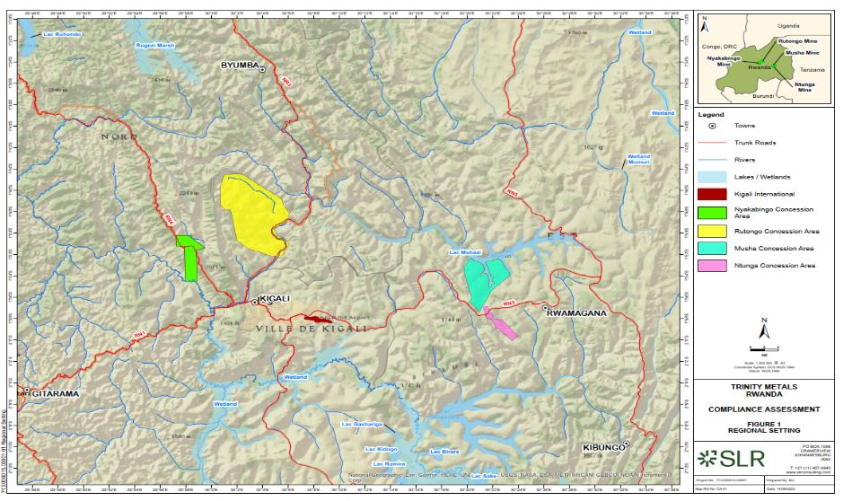
Figure 1: Regional Setting
Figure 2: Rutongo Concession
The rivers are highly impacted by previous and current legal and illegal mining of cassiterite and building aggregate.

Trinity Nyakabingo Mine
Trinity Nyakabingo tungsten ore mine sits 19km (by road) to the northwest of Kigali in the Northern Province, near the village of Shyorongi, in the Rulindo District (Fig 1). The mine produces more than 70 tonnes per month under a 25-year license that began in 2015.
Nyakabingo Mine falls within a 1,600ha concession, which includes state forests, rural settlements and agricultural lands (Fig 3). The mining operations are confined to the top end of a south-facing and steep-sided horseshoe amphitheatre, which forms the headwaters of the Nyakabingo River which enters the large Nyabarongo River roughly 5km from the mine.
Wolfram (68% tungsten ore) is mined from underground workings, accessed by a number of adits and horizontal drives into the face of the slope.
Trinity Nyakabingo is in the processes of undertaking a feasibility study for a new 50tp/h density separation plant on site, which will retreat the extensive tailings which have collected downslope of the operations as well as treating fresh ore, essentially minimising the need for manual panning and sluicing. This project entails the establishment of a new tailings storage facility.
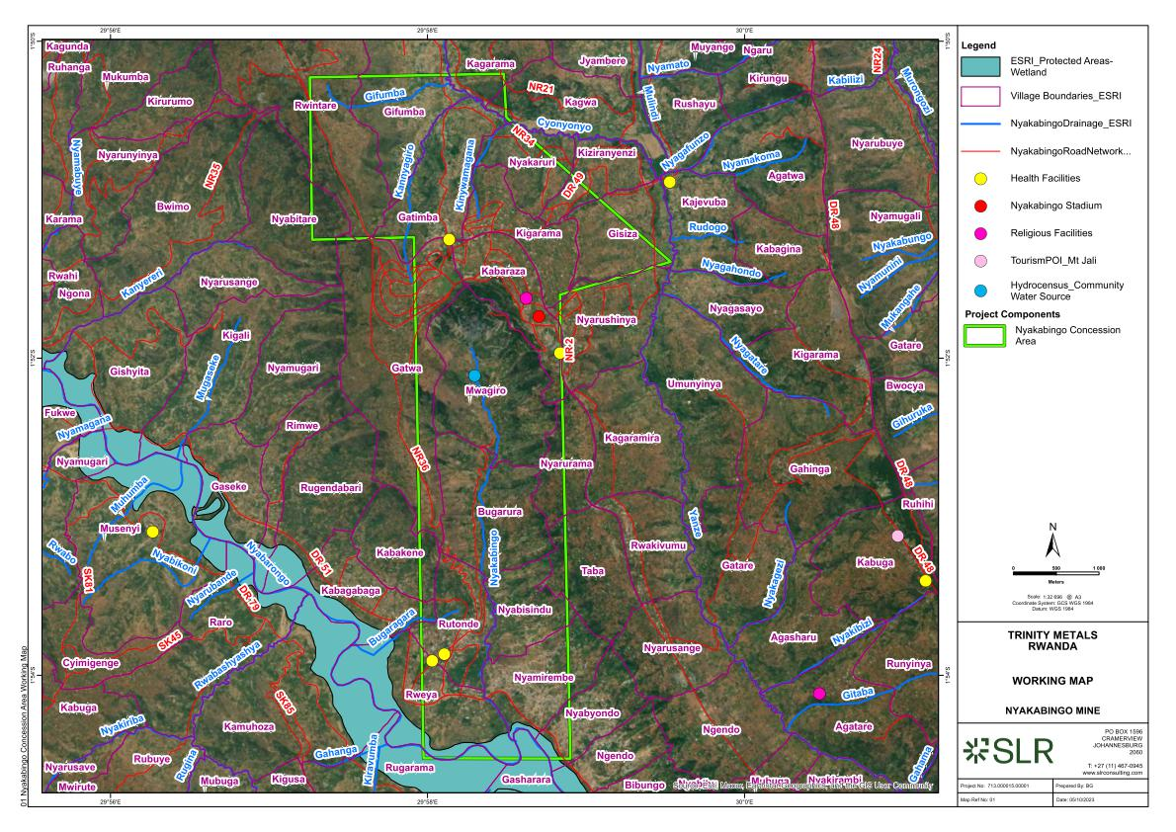
Trinity Nyakabingo employs a workforce of 1730, mostly sourced from within the nearby district.
Figure 3: Nyakabingo Concession
Mining legacy features include old “Belgium” tunnels and workings no longer in use. Mine tailings have accumulated downslope of the working areas in non-engineered dumps and significant volumes have washed down the Nyakabingo valley over time and settled in the streambed. Settlement dams and a return water dam and system have recently been installed to harvest process water and prevent the downslope loss of tailings.

Trinity Musha Mine
Trinity Musha is located in Rwanda’s prolific tin region – Rwamagana District – 45 km from Kigali in the Eastern Province (Fig 1). The mining operations occupy the Musha and Ntunga mining concessions (Figs 4 & 5), which straddles the watershed of two catchments – the Nyabugogo catchment and Lake Muhazi to the north, and the Rwangunda catchment and Lake Mugesera to the south. Musha Mine is on the northern side of the Kigali-Rwamagana road which runs along the watershed, while the Ntunga mining operations are on the southern side of the road. The size of the Musha/Ntunga concession complex is 6,094ha excluding exploration license that is under review by the Rwanda mining Board.
The mines produce around 30 tonnes per month of tin, as well as small amounts of Coltan from the Duha and Ntunga sub-sites, under a 25-year license that began in 2014 under Piran Rwanda Limited. Musha-Ntunga Mine was incorporated into Trinity Metals in 2022, and renamed Trinity Musha Mines ltd.
Cassiterite is mined from underground workings accessed by adits into horizontal drives and by vertical shafts. Although the operation consists of a number of sub-mines, more than 95% of the production comes from the main Musha mines. The primary multi-level workings are accessed by Musha Tunnel in the Musha concession. A number of satellite shafts are operated in the vicinity of Musha tunnel.
Trinity Musha is in the process of developing a new decline (Heza Decline) which will be the future main access to all underground working areas. This will allow for the expansion and mechanisation of mining operations, including drill blast and mechanical tramming. Increased product will necessitate increased mechanical processing capacity, with associated processing plants, waste rock and tailings facilities.
Trinity Musha employs ~2900 people. Many previously unauthorised miners have been absorbed into the workforce.
Mining legacy issues include old tunnels dating back to the 1930s, and surface tailings. Opencast mining occurred in the Ntunga area in the past, leaving deep excavations and high hanging walls in the area underlain by a pegmatite, currently being explored for lithium potential.

Lithium Exploration
Trinity Metals is currently undertaking deep drilling in the Ntunga concession to further define the economic potential for future lithium mining and to evaluate extraction options. Deep drilling to >600m is underway to define the extent of the deposit and to retrieve samples for laboratory testing. Initial results are encouraging, but extensive investigation and feasibility assessments are required prior to defining the resource and incorporating it into the business model.

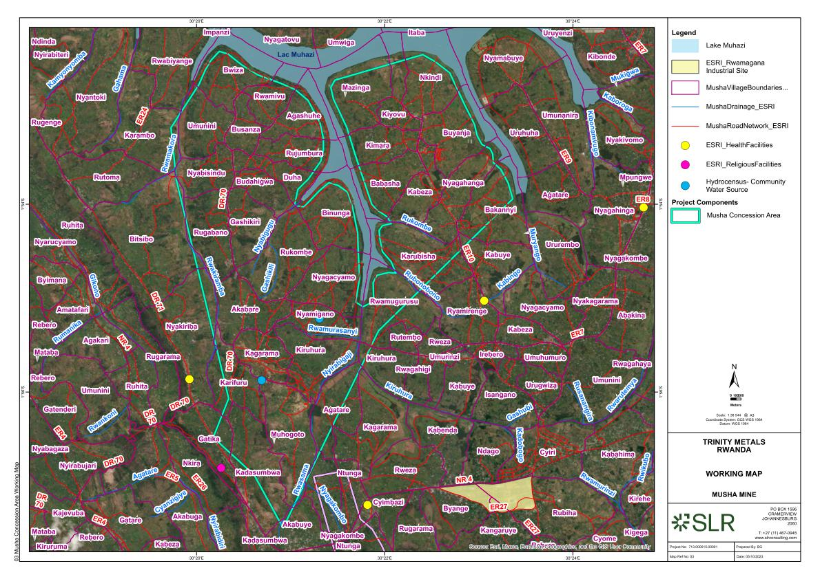
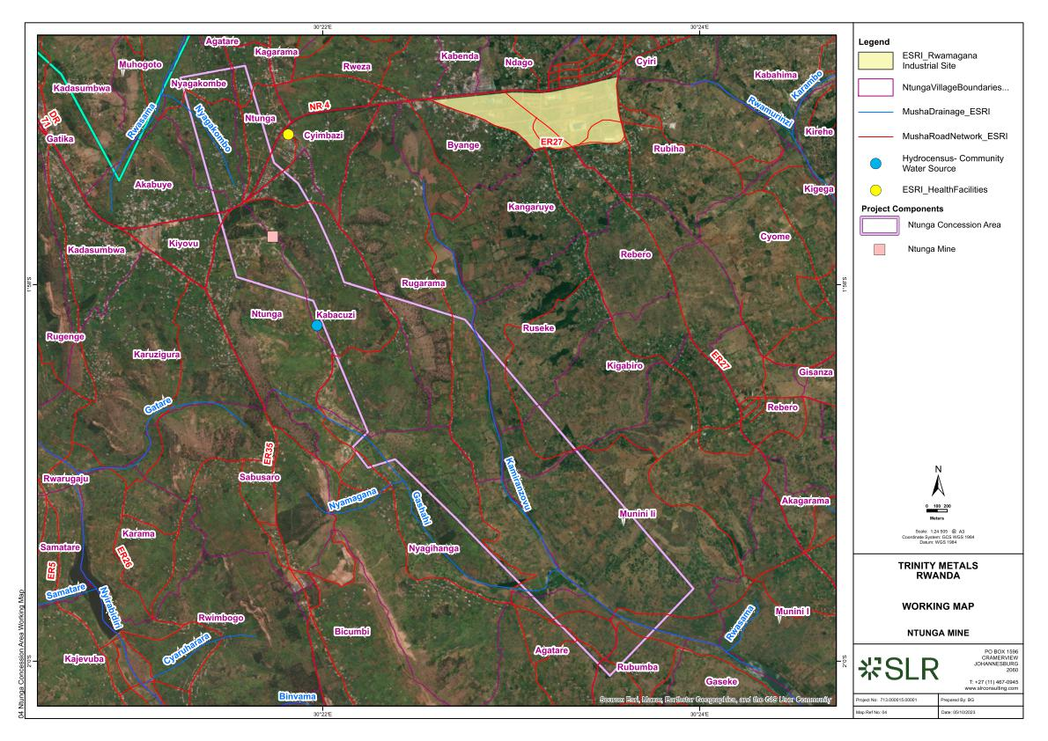
Figures 4&5: The Musha / Ntunga concession Complex

Project Scope
This project involves providing GIS mapping and spatial analysis services to Trinity Metals mining company, with a focus on three key areas:
- Supporting integrated social and environmental planning: Inform land use decisions, environmental protection and rehabilitation measures, and rural development strategies. The GIS work will integrate natural resource data, land cover information, and infrastructure and community assets to guide sustainable and ecologically sound planning.

- Supporting mining and mine planning activities. Provide critical geospatial insights for exploration, infrastructure layout, geotechnical monitoring, environmental permitting, operational planning, rehabilitation and closure strategies.

- Supporting Asset Protection functions and incident reporting. Provide geospatial inputs into effective security for our operations, management of unauthorised mining activities and SHEC incident investigations and corrective actions.

Objectives
- To develop accurate and up-to-date GIS maps for all three of the Company Concessions.
- To integrate spatial data from multiple sources.
- To support analysis, visualization, and reporting.
- To create and maintain a centralized spatial database.
- To provide technical GIS support and training.

Deliverables
The project deliverables will be fully refined in negotiations with the successful candidate, however for the purpose of this SOW, these will include, but are not strictly limited to:
- Topographic and Base Maps (including administrative boundaries; contours; elevation; roads; and water bodies)
- Environmental Thematic Maps (e.g., slopes; land cover; vegetation cover; soils and erosion potential; hydrological systems i.e. rivers, wetlands, floodlines etc; geohydrology, protected areas, environmental zones)
- Social Thematic Maps (e.g., land use, zoning, utilities, settlements, land ownership, community buffer zones, water sources)
- Climate Change Susceptibility Maps (e.g., landslide risk areas; flood risk zones; fire risk areas).
- Mining Lease and License Boundary Maps (including other lease holders within and adjacent to Trinity concessions)
- Geological and Geotechnical Maps (integrated from geological mapping, exploration data and geotechnical assessments)
- Mine Infrastructure Layout Maps (e.g. roads and bridges, mine workings including tunnel entrances, processing plants, tailings facilities, water infrastructure, power lines)
- Incident data (e.g. security or theft incidents, OHS and E&C incidents, unauthorised mining locations, community incidents)
- Geospatial Database with all processed layers and metadata
- Training and Documentation (manuals, SOPs, metadata)
- Geodatabases (e.g., file geodatabase or enterprise database)
- Map Books / Atlases (print or digital formats)
- Web Maps / Dashboards (ArcGIS Online, QGIS Cloud, etc.)

Scope of Work

Data Collection
- Collection of existing spatial data from Trinity Metals mines, including Airbus and LiDAR surveys and imagery, GPS co-ordinates, survey mapping, mining and exploration datasets, specialist environmental and mine rehabilitation datasets.
- Collection of existing datasets from government or other stakeholders.

6.2 Data Processing and Management
- Create, organise and maintain GIS data.
- Georeferencing and digitization of maps.
- Data cleaning, standardization, and quality control.
- Attribute data input and validation.

6.3 GIS Analysis
- Spatial analysis (e.g., buffering, spatial overlays, proximity).
- Suitability analysis for future mine infrastructure planning.
- Remote sensing – data acquisition, interpretation and assessment from various sensors.
- Change detection (e.g., land use and land cover over time).

6.4 Mapping & Visualization
- Creation of static and interactive maps.
- Symbology design and layout composition.

6.5 Database Development
- Design and implementation of geodatabases.
- Data migration and integration from various sources.
- Metadata creation and data cataloguing.

6.6 System Integration & Support
- Integration with other enterprise systems (e.g., asset management, ERP).
- User access and permission setup (if applicable).
- Ongoing technical support and maintenance.

6.7 Trinity GIS Platform Presentation and Training
- Presentation of deliverables to Trinity
- GIS functionality training workshop (one day with key Trinity Staff)

Standards & Compliance
- Use of standard GIS formats (e.g., Shapefile, GeoJSON, GDB).
- Compliance with national and international spatial data standards (e.g., ISO 19115, OGC).
- Adherence to client-specific protocols and branding.

Timeline
Include estimated durations for key phases:
- Data Collection: 2 weeks
- Processing and Analysis: 2 weeks
- Map Production and Database Setup: 4 weeks
- Final Deliverables and Review: 2 weeks

Resources & Tools
- GIS Software (e.g., ArcGIS Pro, QGIS, Global Mapper)
- Cloud-based GIS platforms (e.g., ArcGIS Online, Mapbox, Google Earth Engine)

Assumptions & Dependencies
- Availability of accurate base data and imagery.
- Access to field locations for survey (if needed).
- Timely review and approval by the client.

Exclusions
- Field surveys
- Detailed engineering design.
- Software licensing costs.
- Legal land boundary surveys (unless specified).

Acceptance Criteria
- Accuracy of spatial data within [specify tolerance, e.g., ±1 meter].
- Compliance with agreed symbology and formatting standards.
- Functionality of any web-based GIS applications delivered.

Proposal Submissions
Only suitably qualified and experienced companies need to apply. Previous experience of undertaking such projects is essential and must be provided as part of the proposal submission.
Interested companies are required to submit a detailed proposal and costing for the work described in this Scope of Works. Submission to include full CV’s of those members who will be appointed to the task. Proposals are to be forwarded to the Trinity Metals Group Sustainability Manager as indicated below:
Trinity Metals Group Sustainability Manager: Mr Sam Ryumugabe
Masoro, Rulindo
P.O Box: 6132 Kigali-Rwanda
info.rw@trinity-metals.com
+250 791 959 034
Email: sam.ryumugabe@trinity-metals.com
Phone: 00250 788614722
All enquiries are to be directed in writing to Mr Ryumugabe.

