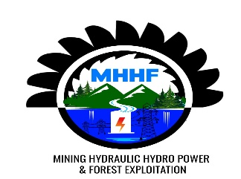

RULINDO DISTRICT date 20/07/2025
SHYORONGI SECTOR
TIN NUMBER : 106586602
Account Number : Access Bank : 1002100101644501
CLIENT: Trinity Rutongo mine

PROFORMA INVOICE

NO | DESIGNATION | UNITY | QUANTITY | U/P | T/P | OBS
 | 20cm*5m | Pcs | 537 | 9,000 | 4,833,000
 | 20cm*3m | pcs | 310 | 8,000 | 2,480,000
 | 15cm*5m | pcs | 517 | 5,500 | 2,843,500
 | Total |  |  |  | 10,156,500

Amount in word : thousand Rwandan francs

MANAGING DIRECTOR

Eng.MANZI MIGERI JOSEPH

