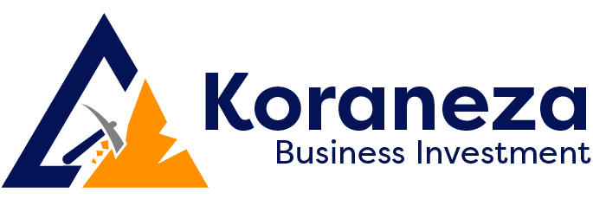

From: KORANEZA BUSINESS IMVESTMENT LTD
TIN: 112948618
TEL: 0787533411
TO RUTONGO MINES LTD
TIN: 101907021
TEL:0784151347

PROFORM INVOICE NO 0018/2025

DATE | ITEMS | UNIT | QUANTITY | UNIT PRICE | TOTAL PRICE
05/05/2025 | Inyange Drinking water | carton | 42 | 5000 | 210000
Total VAT INCRUSIVE

PAYMENT DETAILS
_ACC:100096335247
_BENEFICIAL NAME: KORANEZA BUSINESS INVESTMENT LTD
_BANK NAMES: BK
_CHEQUE

PREPARED BY: ACCOUNTANT
KAGWESAGE SABINE

