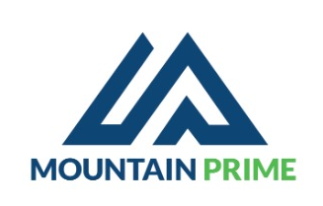
Proforma
Account Number: 8002100101953301 Access Bank
Tel:0788666015
Email:mtprime20@gmail.com
Tin:120695135
Date: 28/4/2025

Client: Trinity Nyakabingo Mine
# | Item | Qty | U.Price (Rwf) | T. Price (Rwf)
1 | Lunch | 1900 | 4659 | 8,852,100
2 | Soft Drinks | 400 | 1836 | 734,400
3 | Amstel & Mitzing | 1464 | 2400 | 3,513,600
4 | Heineken | 36 | 3000 | 108,000

Total 13,208,100

Advance request of 80%

