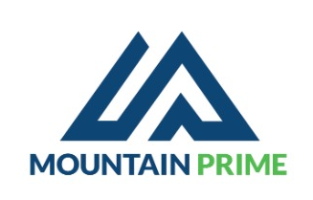
Proforma
Account Number: 8002100101953301 Access Bank
Tel:0788666015
Email:mtprime20@gmail.com
Tin:120695135
Date: 3/4/2025

Client: Trinity Nyakabingo Mine
# | Item | Qty | U.Price (Rwf) | T. Price (Rwf)
1 | Food | 200 | 5500 | 1,100,000
2 | Soft Drinks | 40 | 1800 | 72,000
3 | Local Beers | 156 | 2400 | 374,400
4 | Heineken | 24 | 1700 | 40,800
5 | Wine | 1 | 80,000 | 80,000
6 | Intebe |  |  | 70,000
7 | Teinte |  |  | 75,700

Total 1,812,900 Frw

Advance request of 50%

