Date: 14/01/2025

PROFORMA INVOICE

Client: ETI NYAKABINGO

SUPPLY OF SPARES FOR WATER PUMP

No | Description | Qty | Rate | Total Price
1 | IMPELLER (BRONZE) | 8 PCS | 1.203.250 | 9.626.000
2 | DIFFUSER CAST IRON | 7 PCS | 1.203.250 | 8.422.750
3 | KIT BEARINGS | 4 PCS | 406.800 | 1.627.200
GRAND TOTAL |  |  |  | 19.675.950

-Delivery time: Spares are available in stock
-Payment modality: 100%
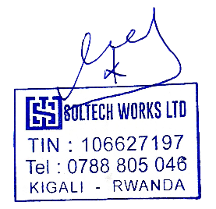
-Offer validity: 30 days

SOLTECH WORS LTD
Managing Director

