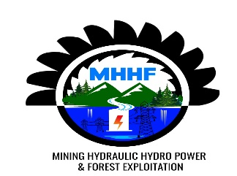

RULINDO DISTRICT date: 28/02/2025
SHYORONGI SECTOR
TIN NUMBER: 106586602
Account Number: Access Bank: 1002100101644501
CLIENT: TRINITY NYAKABINGO MINE

PROFORMA INVOICE

NO | DESIGNATION | UNITY | QUANTITY | U/P | T/P(Rwf)
1 | 20cm*3m | Pcs | 30 | 8000 | 240,000
2 | 15cm*5m | Pcs | 170 | 5,500 | 935,000
3 | 20cm*5m | Pcs | 140 | 9000 | 1,260,000
 | TOTAL |  | 400 |  | 2,435,000

MANAGING DIRECTOR

Eng.MANZI MIGERI JOSEPH

