Tel:0786990226
avivomedialtd@gmail.com
Address:Kigali-Rwanda
Tin Number:120415006
Billing To:
QUOTATION
Trinity Metals
Invoice : 008
PROJECT NAME: Printing and branding _{Date : 17 Feb 2025}
SL | Item Description | QTY | Rate | Amount
1 | Branding Exectutive crystal awards | 2 | 120.000 | 240,000
2  3 | Printing certificates with wooden frames  Branding Notebooks | 4  68 | 7.000  5000 | 28,000  340000
Payment Method
Ecobank Account:6780004262
Momo Pay:912769 | Total RWF:608,000

Grand Total tax inclusive RWF:608,000
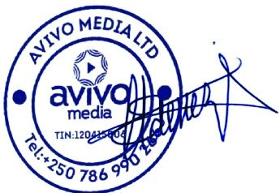Design-Printing-Ads & Media Production

