Date: 27/01/2025

PROFORMA INVOICE

Client: ETI NYAKABINGO

REPAIRING TWO PUMPS AND SPARES PARTS HMU50/6

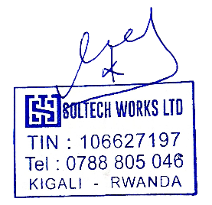
Qty | Description | Unit Price | Total Price
2 PC | NEW IMPELLER STAINLESS STEEL | 1,200,250 | 2,400,500
10 PC | MACHINING OF DIFFUSER CAST IRON (REPAIR) | 205,000 | 2,050,000
2 PC | SLEEVES STAINLESS STEEL | 240,770 | 481,540
12 PC | BRONZE BUSHES FOR PUMP | 254,780 | 3,057,360
6 PC | OIL SEALING RUBBER | 30,030 | 180,180
4 PC | KIT BEARINGS | 180,000 | 720,000
FF | LABOUR COST FOR REPAIRING FOR TWO PUMP | 500,000 | 1000,000
Total price |  |  | 9,889,580

VAT 18% IS INCLUSIVE
Payment: 100%
Time of Repairing 14 days
DONE AT KIGALI 27/01/2025

SOLTECH WORS LTD
Managing Director

