NYAKABINGO WOLFRAM HOST ROCK DEPTH EXTENT DRILLING
- INTRODUCTION
In the view of the ongoing resource estimation work at Nyakabingo, there is an uncertainty over how deep veins mined and mapped from underground excavations extend. Geology models have been extended to an elevation of 1000 metres (figure 2). However, it is uncertain whether the veins or the host rock extend to this elevation. It is therefore recommended that two test diamond drillholes be drilled from the surface to depths of ~700 metres (along an inclination of 70 degreed, figure 1 and 2). These test holes will add extra knowledge and confidence on the resource estimates and will therefore justify any future mine infrastructure below BV22, particularly before the current decline advance deeper.
- PLAN
The aim is two drill 1400 metres with two holes, 700 metres each as shown in the table 1 below and figures 1 and two. It should take two months or less to complete these holes. All the required funds and resources are detailed in section three.
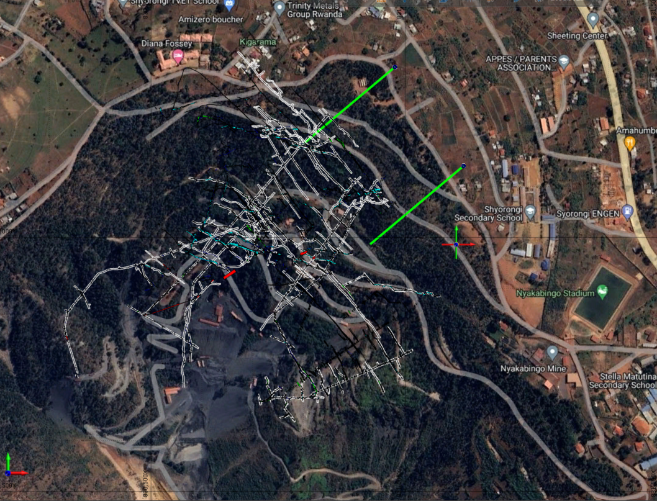

Figure 1. Plan View of the planned drillholes at Nyakabingo (green lines).

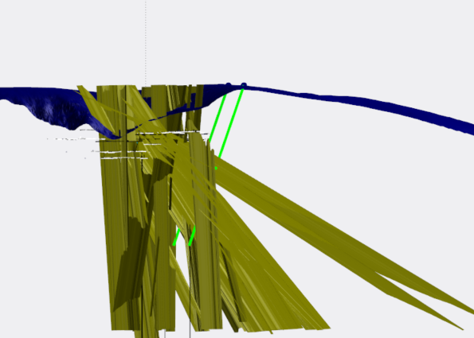

Figure 2. Section view of the planned drillholes at Nyakabingo (green lines)

Hole ID | Easting | Northing | RL | Target Depth | Azimuth | Inclination
NYDD_01 | 831114.60 | 9794140.50 | 2000.00 | 700.00 | 230.00 | -70.00
NYDD_02 | 830979.70 | 9794335.30 | 2006.00 | 700.00 | 230.00 | -70.00
Tble 1. Details of the planned drillholes

- COSTS
Assumptions are that the wholes will take 6 weeks, as learned from Ntunga drilling and all the resources are assumed to be the same as Ntunga drilling. Rates are not changed from the Energold offer.
Table 2. costs of the test drillholes.
No | ITEM | QUANTINTY | UNIT COST$ | TOTAL COST$
1 | Mobilisation | 2 | 3,000 | 6000
2 | Demobilisation | 2 | 3,000 | 6000
 | Drill Rate (PQ)
3 | 0 to 100m | 200 | 127 | 25400
 | Drill Rate (HQ)
4 | 101 to 200m | 200 | 125 | 25000
5 | 201 to 300m | 200 | 130.5 | 26100
6 | 301 to 400m | 200 | 136.5 | 27300
 | Drill Rate (NQ)
7 | 401 to 500 | 200 | 139.95 | 27990
8 | 501 to 600m | 200 | 146.95 | 29390
9 | 601 to 700m | 200 | 154.45 | 30890
9 | Fuel | 200 | 96 | 19200
10 | Others Charges
 | Sampling Crew
11 | Sampling Consultant | 1 | 3500 | 3500
12 | Sampling crew | 4 | 250 | 1000
13 | Offsiders | 2 | 120 | 240
14 | Project Geologist | 1 | 8000 | 8000
15 | Resource estimation study | 0 | 30000
 | Lab analysis
 | Lab tests and samples shipment | 600 | 40 | 24000
 | Other Logistics
16 | Car Rental | 2 | 1100 | 2200
17 | Crop/Land expropriation | 2 | 2100 | 4200
18 | Water Tank 10,000L | 3 | 750 | 2250
19 | Water Transport | 2 | 3000 | 6000
 | Drill Consumables
20 | Core Trays PQ | 50 | 6.5 | 325
21 | Core Trays HQ | 150 | 6.5 | 975
22 | Core Trays NQ | 200 | 6.5 | 1300
23 | Core blocks | 1000 | 0.51 | 510
24 | Red Chinagraph pencils - box | 1 | 1.5 | 1.5
25 | Green Chinagraph pencil - box | 1 | 1.5 | 1.5
26 | White Chinagraph pencil - box | 1 | 1.5 | 1.5
27 | Calico bags | 1000 | 0.4 | 400
28 | Permanent markers - box | 2 | 8 | 16
29 | Aluminium sample tags | 1000 | 0.15 | 150
30 | Core saw blades - green saw | 3 | 500 | 1500
31 | Core saw blades - yellow saw | 3 | 400 | 1200
32 | Flagging Tape-pink, box | 2 | 3.2 | 6.4
33 | PPE | 12 | 30 | 360
34 | Hand lense | 2 | 8 | 16
35 | Whiteboard | 1 | 30 | 30
36 | Photo rack (1*2) | 1 | 36 | 36
37 | Core tables (1*3) | 4 | 218 | 872
38 | Angle iron 3 m | 8 | 127 | 1016
39 | CRM high | 40 | 5.95 | 238
40 | CRM medium | 40 | 5.95 | 238
41 | CRM Low | 40 | 2.13 | 85.2
 | Total BT |  |  | 283,938
42 | Taxes and fees Estimates (20%) |  |  | 56,788
 | Sub Total |  |  | 340,726
43 | Contingency |  |  | 51,109
 | Grand Total |  |  | 391,835

- CONCLUSION
Although the test drillholes will not be solely relied on during the resources estimates, the information to be gained will add more confidence on the resources estimates and hence support in the ongoing mine infrastructure development such as the decline, the processing plant and dams and tailing facilities. It is therefore important to drill these two holes.

