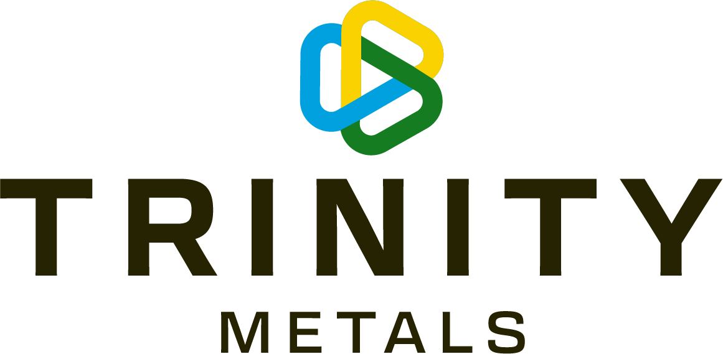

SAFETY, HEALTH, ENVIRONMENT AND COMMUNITY PLEDGE
With my hand stamp, I’m a committed SHEC Leader, proudly working for the Mining Company that sees the safety and care for its people, and the protection of our community and environment as a top priority. We believe that everyone, (employees contractors, and community) has the right to go home safely to their families every day and has the right to a clean and healthy environment.

I hereby pledge:
- To undertake my duties with intent to do no harm to people, planet and profits.
- To never compromise my own safety or the safety of my co-workers to get the job done.
- To actively look for hazards, promptly report them and take appropriate action to remove the hazards.
- To be a visible safety leader, being a good role model in my day-to-day actions in the workplace.
- To coach and train my team members and provide them with the tools to do their jobs safely and effectively.
- To engage my team members constantly to ensure they are focused and aware of the risks associated with their job and the working environment.
- To create a workplace culture whereby any employee or contractor (no matter what level) has the right and willingness to stop any unsafe work.
- To set standards to manage the risks in the workplace, to live the standards (hold myself accountable) and ensure my team always complies with these standards.
- To respect and protect the human rights of my co-workers and of the communities in which we work.

Signed on January 26^{th,} 2024
All the General Managers, the Leadership Team, management, and Safety personnel from the three mines

