
ECOVATECH Ltd
KIGALI-RWANDA (Near Hotel Gloria)
TEL: 0785063158, 0791 501 257

TIN/VAT: 106919171
Acc: 00040-06940973-80 (Bank of Kigali A/C)
ECOVATECH Ltd Acc.• 4004201081241 (Equity)
Email: ecovatech2020@gmail.com
FACTURE PROFORMA NO: 015
No | Items Descriptions | Qty | U.P | T.Price
1 | HP DESKTOP COMPUTER PC MODEL  290G4/10TH GEN/CORE i5,  MEMORY: 16GB DDRIV  STORAGE: 512GB SOLID STATE  DRIVER  DISPLAY: 21.5'' INCHES MONITOR  WINDOWS 11 LICENCE | 2 | 780,000 | 1,560,000
2 | HP PROBOOK LAPTOP MODEL 450,  GENERATION 12TH/ CORE i5  PROCESSOR  MEMORY: 16GB DDRIV  STORAGE: 1TB SOLID STATE DRIVER  WEBCAM, WIRELESS  DISPLAY: 15.6'' SCREEN  WINDOWS 11 GENUINE 64BIT  PROFESSIONAL | 1 | 990,000 | 990,000
 | VAT IS EXEMPTED |  |  | -
 | Delivery Lead Time: After receiving the PO |  |  | -
GRAND TOTAL VAT EXEMPTED |  |  |  | 2,550,000

Date:28/03/2024
M/S: RUTONGO MINES
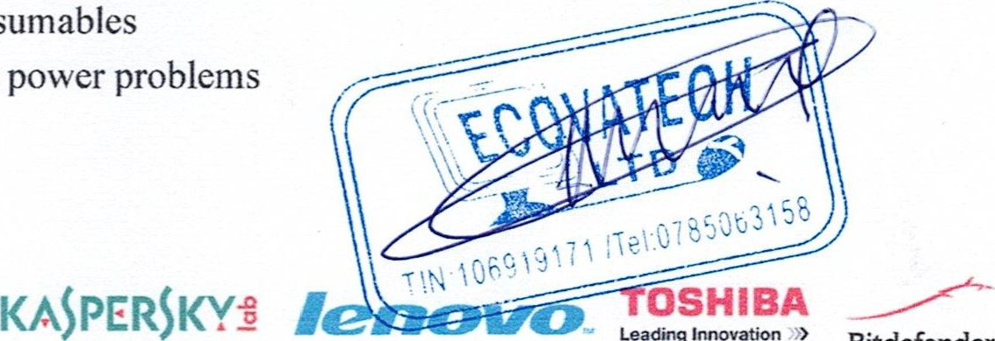
No warranty on consumables
No warranty against power problems
 Bitdefender

